BOPTEST Reference Test Case Peer Review Document

This document serves a peer review template for an emulation model that is to be a reference test case. There are four sections:

I. General Information

II. General Comments

III. Model Checks

IV. Test Case Checks

Section I is to be completed by the Model Developer. The remaining sections are to be completed by the designated Model Reviewer, and returned to the Model Developer so that they may make the appropriate edits. This process should be repeated until all concerns of the reviewer are addressed. Each review should be documented using a separate version of this document, specified by the Review # in Section 1 below.

# I. General Information

|  |  |
| --- | --- |
| **Reference Case** | Individual house 100 m2 (8 thermal zones) with hydronic heating system |
| **Current Location** | Bordeaux, France |
| **Model Developer** (Name, Institution, Email) | Jessica Leo, Valentin Gavan, ENGIE Lab  [valentin.gavan@engie.com](mailto:valentin.gavan@engie.com) |
| **Model Reviewer**  (Name, Institution, Email) | Krzysztof Arendt, Center for Energy Informatics, The Maersk Mc-Kinney Moller Institute  [krza@mmmi.sdu.dk](mailto:krza@mmmi.sdu.dk%20%20) |
| **Review #** | 1 |

# II. General Comments List each comment in separate row with number. Additional rows may be added as needed. They should be supported by the responses in Sections III and IV.

|  |  |
| --- | --- |
| **#** | **Comment** |
| 1 | Finish documentation |
| 2 | Translate comment and block names in the high-level model |
| 3 | Implement minor changes concerning the control system, after discussion in Aachen |

# 

# III. Model Checks

|  |  |
| --- | --- |
| **Criteria** | **Reviewer Response** |
| **Reference Case Representation** |  |
| Does the model represent overall intent of reference case?  Are the relevant thermal systems, heat loads, and control signals accounted for? | Yes |
| **Climate** |  |
| Complete weather data file, similar to TMY? | Yes (.epw 🡪 .mos) |
| Sufficiently long period, e.g. one year? | Yes |
| **Internal Gains** |  |
| Occupancy schedule? | Yes, conventional (building energy regulation compliance calculation) for the French context. Weekly based and then repeated over the entire year (1 week of holiday in December and in August) |
| Occupancy gain values reasonable for building type? | Yes (90W, 0.65/0.35 for conv;/rad.; modifiable) |
| Lighting schedule/control? | Yes, based on the occupancy for the time variation. |
| Lighting gain values reasonable for building type? | Yes, according to the French context (e.g. 1.1 W/m²) |
| Equipment schedule? | Yes, based on the occupancy for the time variation. |
| Equipment gain values reasonable for building type? | Yes, according to the French context (e.g. 5.7 W/m², to be discussed, seems to be quite high) |
| **Envelope Modeling** |  |
| Are IDEAS, Buildings, or AixLib component models used for building envelope and window modeling? | Yes, Buildings |
| If not IDEAS, Buildings, or AixLib component models, are dynamic wall heat transfer models used? | NA |
| If not IDEAS, Buildings, or AixLib component models, are complex fenestration models used? | NA |
| It not IDEAS, Buildings, or AixLib component models, is latitude and longitude consistent with intended region or weather file? | NA |
| It not IDEAS, Buildings, or AixLib component models, are convection models for inside and outside nonlinear? | NA |
| Are window surface areas reasonable? | Yes, 1/6 of the building footprint |
| Are insulation levels reasonable? | Yes, the model was developed to match the building energy regulation requirements (e.g. 8 cm with 0.032 W/mK). |
| Are all surfaces accounted for? (e.g. the roof is not forgotten) | Yes |
| Which of the following is used for modeling air infiltration?  *None*  *Constant*  *Pressure-driven flow*  *Buoyancy-driven flow*  *Mixed pressure and buoyancy-driven flow* | Constant |
| Inter-zone airflow and common wall heat transfer properly accounted for? | Yes (e.g. through doors, needs review) |
| Are the inside and outside radiation models appropriate? | Yes (detailed mixed air zone model from the Buildings library) |
| **HVAC Modeling** |  |
| Are moisture and condensation effects properly accounted for? | ? (using Buildings.Media.Air) |
| Are fluid components such as ducts, pipes, actuators, pumps, fans, and heat exchangers modeled with pressure-flow relationships? Are pressure drops reasonable? | Needs validation. |
| Is the heat transfer performance of other equipment such as heat exchangers and plant equipment modeled reasonably? | Needs validation. |
| Are equipment capacities reasonable? | Yes |
| Are equipment efficiencies such as COP, heating, hydraulic, and motor reasonable? | Yes |
| Is a reasonable level of control provided such that the model can simulate without use of external controller? | Yes |
| **External control Input Signals** |  |
| Reasonable given state of the art actuation? | ??? |
| Units assigned? | ??? |
| **Measurement Output Signals** |  |
| Reasonable given state of the art sensors? | ??? |
| Are all equipment power/fuel consumptions computed and measured for KPI calculations? | ??? |
| Are all zone temperatures measured for KPI calculations? | Yes, needs discussion on the blocks naming strategy and to be aligned with the KPIs |
| Units assigned? | Yes |
| **Compilation and Simulation** |  |
| Uses official library release versions (with Modelica “Uses” statement)? | Yes |
| Can be compiled into FMU free of commercial licensing? | ??? |
| Simulates for full year? | Yes, need review to optimize the simulation time |
| Compatible with variable time-step solver? Otherwise, minimum timestep acceptable? | Tested with DASSL |

# 

# 

# 

# IV. Test Case Checks

|  |  |
| --- | --- |
| **Criteria** | **Response** |
| **Documentation** |  |
| Building Design and Use (including architecture, constructions, occupancy schedules and comfort, internal loads and schedules, climate) | Incomplete |
| HVAC System Design (including primary and secondary system designs, equipment specifications and performance maps, rule based and/or local loop controllers) | Incomplete |
| Additional System Design  (such as lighting, shading, onsite generation and storage) | Incomplete |
| Points List (including control inputs signals and measurement output signals with descriptions and meta-data) | Incomplete |
| Important Model Assumptions  (such as infiltration models, moist/dry air assumptions, well-mixed assumptions) | Incomplete |
| Scenario Information (including energy pricing and emission factors) | Incomplete |
| HTML template followed? | ?? |
| **KPI Calculations and Scenario Information** |  |
| JSON map for matching output signals to KPI calculation provided? | No |
| Reference comfort temperature(s) for each zone provided? | No |
| GHG emission factors provided? | No |
| Pricing scenario 1 (constant) provided? | No |
| Pricing scenario 2 (dynamic) provided? | No |
| Pricing scenario 3 (highly dynamic) provided? | No |

**Model description**

**Building**

The modeling focuses on one type of residential building, in accordance with the French Thermal regulation 2012 (French national building energy regulation). The building typology is defined in such way to be representative of French new dwellings.

The model represents a detached house of approximately 100 m² (*S_ref*). The building floor surface can be modified by the user in order to model the effect of the building size. This can done by changing the value of the variable *S* in the model. The dimensions of the building elements (surfaces) will be then automatically calculated accordingly to the new value.

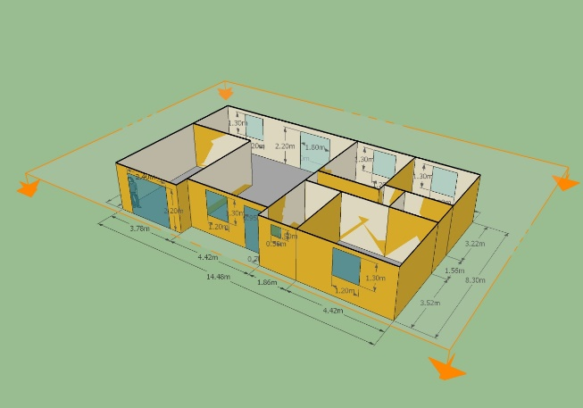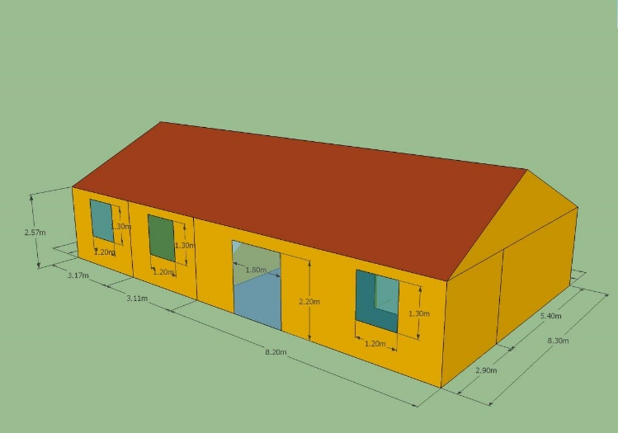

Figure 1. Simulated single floor house (SFH)

The orientation of each building was chosen in order to maximize the natural light during winter. Thus, the main surface of windows of the building is south oriented. The building consists of :

* 1 living room / kitchen
* 3 bedrooms (2 South facing, 1 North facing)
* 1 bathroom
* 1 corridor serving the sleeping area (bedrooms and bathroom)
* 1 unheated garage
* unheated attic

The building envelope of each building was defined in order to cover the new construction modes existing on the market. Thus, each of these modes was characterized by a different level of insulation (Table 1).

Table 1.Building envelope characteristic

|  |  |
| --- | --- |
| **Wall type** | **Characteristics** |
| **External wall** | Brick (200 mm, λ=0.2 W/mK) + polystyrene (80 mm, λ=0.032 W/mK) |
| **U = 0.272 W.m-2.K-1** |
| **Floor** | Hollow block (150 mm, λ=0.92 W/mK) + polyurethane (60 mm, λ=0.022 W/mK) |
| **Ue = 0.327 W.m-2.K-1** |
| **Ceiling** | Glass wool (200 mm, λ=0.04 W/mK) |
| **U = 0.193 W.m-2.K-1** |
| **Fenestration** | Double glazing with Argon and PVC frame 4/16/4,  Planitherm glass g=0.6, TL=76% with external solar protection |
| **Uw = 1.40 W.m-2.K-1** |

These values (in accordance with the French Thermal regulation 2012 (can me modified by the user or automatically using a script.

The building was subject to a detailed modeling according to the architecture plans. The volume was divided into 8 thermal zones according to space function (an additional thermal zone was created to simulate the behaviour of the attic). Each space (room) has its own thermal behaviour as a result of the boundary conditions (climate, adjacent spaces, etc.) and the internal conditions (internal loads, scenarios, etc.).

The thermal bridges effect was taken into account by the intermediate of thermal resistance parameterized with the length building element assimilated to the thermal bridge and a thermal bridges coefficient (*k_PT*).

The thermal zones of the building, except the unheated zones, are subject to conventional scenarios (occupation, heating, cooling, ventilation, lighting, internal loads) defined in the French Thermal Regulation 2012 (CSTB - Centre Scientifique et Technique du Bâtiment), 2012. Méthode de calcul Th-BCE - Réglementation thermique 2012; CSTB, 2012).

For example, the building is considered occupied continuously by four adults from 19PM to 10AM for 4 weekdays, from 15PM to 10AM during all Wednesdays and all day long during weekends. On an yearly basis, the building is considered unoccupied one week at the end of December and two weeks in August. A reduction of 30% of the internal loads due to occupants is observed during the nighttime.

The building set-up temperature value for heating is fixed conventionally at 19°C during occupation period, 16°C during an inoccupation period inferior to 48 hours and 7°C otherwise. The scenario for cooling is similar, the set-up values are 28°C / 30°C / 30°C. These values can me modified by the user or automatically using a script.

The internal loads considered are mainly due to lighting and appliances. For lighting, approximately 1.1 W/m² are considered (according to (CSTB - Centre Scientifique et Technique du Bâtiment), 2012. Méthode de calcul Th-BCE - Réglementation thermique 2012; CSTB, 2012), 80% of the 1.12 W/m² installed power is transformed in heat). Appliances contribution to internal loads are considered at a level of 5.7 W/m² from 7AM to 10AM and from 19PM to 22PM for 4 weekdays, 7AM to 10AM and from 15PM to 22PM during all Wednesdays and all day long during weekends. Otherwise, this level is reduced by 80%. All this elements can be modified by the user. These values can me modified by the user or automatically using a script.

**Systems**

Each building zone has its own radiator equipped with a thermostatic valve and a temperature controller (PI) connected to the zone temperature, setpoint (a correction coefficient will add 0 to 2.5°C to take into the spatial variation of the control system is implemented; the default value is 0) and the sending order to the valve. The radiators are designed with the regard of building envelop characteristics and based on the specific climate of Bordeaux, France (FRA_Bordeaux.075100_IWEC.mos).

The water is heated by a gas boiler. The boiler is designed to provide power (sum of the radiators nominal power) for heating only (the DHW production is not take into account in this model).

**Control**

The boiler is operated by a control system composed of a set of controllers:

* The controller (PI) in charge of the security of the output temperature of the boiler will observe the nominal supply temperature (90°C) and the supply temperature provided by the boiler.
* The controller (Hysteresis) in charge of the On/Off mode of the boiler is responsible to provide an order signal based on the indoor air temperature setpoint (from the occupancy schedule) and the measured indoor air temperature (we have chosen in this model to take into account the Living room temperature – thus the On/Off controller is considered to be placed in this specific thermal zone of the building).
* If a delta of temperature is observed between the indoor air temperature setpoint and the indoor air temperature in the Living Room (controller (Hysteresis) signal is True), an additional PI controller will be in charge of the calculating the signal for the load ratio of the boiler (a minimum PLR of Pmin_Ch/Pmax_Ch equal to 11% is imposed in this controller).

The signals from these three controllers are combined and connected to anti short cycle system and the connected to the boiler control input signal. The anti short cycle system is comparing the operating time of the boiler between two start/stops. This operating time should be greater than 600 seconds to allow the boiler to stop or start. This system should improve the overall boiler performance.

The boiler is equipped with a pump (is responsible for circulating the water through the radiators) which is performance is with a performance map here. This pump is switched On based on a signal of a PI controller observing the indoor temperature setpoint input (from the occupancy schedule) and the measured indoor air temperature.

A heating water temperature block (capable to calculate the supply temperature for heating with the regard of the outdoor air temperature) is connected to a 3 way valve in order to limit the supply temperature.